
LA GRANDEE INTERNATIONAL COLLEGE
Simalchaur, Pokhara Nepal
A Project Proposal
On
“Bus Reservation System”

Submitted to:
Bachelor of Computer Application(BCA) Program
In partial fulfilment of the requirements for the degree of BCA under
Pokhara University
Submitted by:
Name: | Course | Semester | P.U. Registration Number
Manisha Timilsina | BCA | 2nd | 2025-1-53-0332
Prapti Ghimire | BCA | 2nd | 2025-1-53-0339

Date:10/06/2026

Declaration for
“Project Title”
Student’s Declaration
I (We) hereby declare that I (we) am (are) the only author(s) of this work and that no sources other than the listed here have been used in this work.
____________________________
Name of the Students
NAME, EXAM ROLL NO
Program, Semester
Date:____ / ____ / ________

Supervisor’s Declaration
I hereby recommend that this project entitled “Project Title” is done under my supervision by Student Name1 and Student Name 2 during their _th Semester in partial fulfilment of the requirements for the degree of Program Name under Pokhara University is completed to my satisfaction and be processed for final evaluation.

____________________________
Name of the Supervisor
Date:____ / ____ / ________

Letter of Approval
We certify that we have examined this report entitled “Project Title” and are satisfied with the project defence. In our opinion it is satisfactory in the scope and qualify as project in partial fulfilment of the requirements for the degree of Program Name under Pokhara University.

________________________  Supervisor  Arpan Pokhrel | ________________________  Examiner  Date:____ / ____ / ________ | ________________________  Program Coordinator

TABLE OF CONTENT

1. Introduction 7
2. Problem Statement 9
3. Objectives 10
4. Background Study 11
5. Requirement Document 13
5.1 Functional Requirement 13
5.2 Non Functional Requirement 13
6. Use Case 14
7. Detailed Timeline 15
8. Gantt Chart 16
9. Future Enhancements 17
12. Annexures 19

LIST OF FIGURES
Figure 1Use case diagram 14
Figure 2Waterfall model 15
Figure 3Gantt Chart 16

Introduction
A bus reservation system is a digital platform that automates bus scheduling, seat availability tracking, ticket sales, and passenger management. It streamlines operation for fleet operator and allows travellers to effortlessly search routes, select seat, and purchase ticket online. The bus reservation system is designed to automate online ticket purchasing through an easy-to-use online bus booking system.
The Bus Reservation System project focuses mainly on reserving online bus ticket. To be more precise, this system helps to keep track of the bus schedule and their management. Also, the system displays all the available buses. In addition, the system allows ticket cancellation and the bus operator can update the seat available. This project contain customer, admin, and bus operator panel.
The customer can simply filter the available seat and book the tickets if seat available by logging in to the system using username and password. An admin or the administrative have the full authority and control to the system. S/he can manage reservation, services, customer detail, and so on. For reservation management, an admin can view every detail of the costumer and bus operator. Here the administrator can update the ticket status of the customer, the seat availability and bus available.
The main objective of this system is to simplify the ticket booking process and improve the overall efficiency of bus transportation services. By replacing manual procedure with a digital system, the chances of error are reduced, record can be maintained accurately, and information can be retrieved quickly whenever needed. The system also saves time and effort for both passenger and operators.
This project is developed using C programming language and focuses on implementing the core functionalities of a bus reservation system. This functionalities include viewing available seat, available buses, reservation, cancellation, and managing customer information. This system stores and processes data efficiently, ensuring smooth operation and better service management.
The Bus Reservation System serves as a practical application of programming concept such as structures, functions, file handling, and data management. It demonstrates how computer technology can be used to solve real world problems and improve service delivery in the transportation sector. The successful implementation of this system will provide a reliable, fast, and efficient solution for bus reservation and management.
The Bus Reservation System developed in C programming focuses on implementing the fundamental concept of programming such as functions, arrays, file handling, loop, and conditional statements. This project provides practical knowledge about software development and database like record management using files. The proposed system includes several important modules such as login management, ticket booking, ticket cancellation, and checking bus status. The login modules provide authentication for user and administrators. The booking modules allows user to select buses and reserve seats according to availability. The cancellation modules helps users to remove their reservation when necessary, while the bus status modules shows the details about buses and available seats. These modules work together to create a complete and effective reservation management system.
Another important objective of this project is to reduce the workload os manual administration. In traditional system, maintaining passenger details manually is difficult and time consuming. There is always a possibility of duplicate booking, calculation mistakes, and loss of records. By introducing a computerized reservation system, these problem can be minimized. This project ensures proper storage and retrieval of information, making the management process easier and more efficient.
In conclusion, The Bus Reservation System is an important and useful application that helps to modernize the traditional ticket booking process. It provides an efficient, secure, and user friendly method for bus reservations. By automating tasks like booking processes, cancellation, and checking bus status, the system saves time, reduces human errors and improves overall service quality. Therefore, the development of a Bus Reservation System is educationally valuable and practically beneficial for transportation management.

Problem Statement
There were many difficulties as this was our first programming based project. Although there were many problems we were able to solve an implement it on our project. Lots of errors and many failures occur while attempting the entire task given in this project. Data collection, multiple seat booking, data was inaccurate, adaptation in system according to government policy and organizational change were difficult in the existing system. So to overcome these difficulties our program was intended.
Many bus companies in Nepal still uses manual ticket booking systems based on hand written records and paper tickets. Problem such as ticket duplication, incorrect record keeping, and loss of booking information are common in traditional system. Managing ticket cancellation and updating seat status manually create confusion for bus operators.
List of the following issues as secondary but prominent issues can make problem statements in both micro and macro level:
- Long waiting in queue
- Difficulty of getting tickets during special occasion
- Lack of computerized system in many areas
- Overcrowding and seat unavailability
- Duplicate or incorrect booking
- Poor management of ticket cancellation
- Time consuming in manual booking
- Risk of losing ticket

Objectives
There is a need for a computerized reservation system that can automate ticket booking and record management. The increasing population and urbanization have increased the number of bus passenger significantly.
Some of the main objective of this project are:
- Provide secure user login using username and password
- Allow passenger to book and cancel bus tickets easily
- Display bus details, maintain and update seat available
- Reduce manual errors in ticket reservation and improve speed and efficiency
- Simple and user friendly menu driven interface

Background Study
Transportation continues to play a vital role in the daily lives of people, especially in developing countries like Nepal where a large number of people will depend on buses for travelling from one place to another. With the continuous growth in population and urbanization, the number of passenger using public transportation is increasing significantly. As a result, traditional manual reservation systems face many difficulties in managing passenger record, ticket booking, and seat availability efficiency.
In many areas of Nepal, passengers still have to visit the ticket counter physically or contact the booking agency through phone calls to reserve seats. This process consumes time and may create inconvenience for passenger. Manual booking methods also increase the chance of human errors such as double booking, incorrect ticket entries, loss of record, and difficulty in maintaining passenger information properly.
Bus operators face challenges in handling large amount of reservation data manually. Preparing reports, checking seat availability, updating schedules, and managing costumer details become difficult and time consuming. The lack of proper digital management system may also reduce service efficiency and costumer satisfaction.
To overcome these problem, a Bus Reservation System will be developed as a computerized solution for managing bus tickets reservation and related activities. This system will help bus operators store and manage records systematically and securely. The proposed system will reduce paperwork and minimize the dependency on manual processes. It will save time for both passengers and bus operators while improving the accuracy of reservation management. The system will also help in reducing booking conflicts, maintaining proper records, and generating reports more effectively.
With the advancement of information technology, computerized reservation systems will become increasingly important in the transportation sector. Many organizations and transportation services will adopt digital systems to improve operational efficiency and provide better customer service. In the context of Nepal, implementing a Bus Reservation System will support the modernization of public transportation management and improve the travel experience for passengers.
Furthermore, the system will provide a reliable and user-friendly environment for ticket booking and management. It will increase transparency in reservation activities and help passengers access transportation services more conveniently. The development of such a system will therefore contribute to improving the quality, efficiency, and reliability of bus transportation services in the future.

Requirement Document

Functional Requirement
- Login System
- Main menu
- User menu
- Bus information management
- Ticket booking
- Ticket cancellation
- Log out system

5.2 Non Functional Requirement
- Performance
- Security
- Reliability
- Usability
- Maintainiability

Use Case
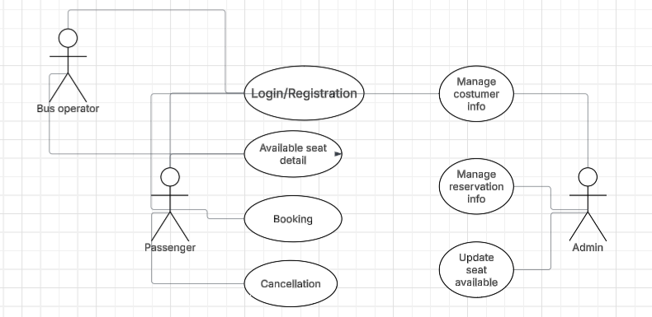
Figure 1Use case diagram

Detailed Timeline
The Waterfall model is a traditional, linear, and sequential software development life cycle(SDLC) approach where each phase, requirements, design, implementation, testing, deployment, and maintenance must be completed before moving to next step. This model is suitable for project with stable and well defined requirements.
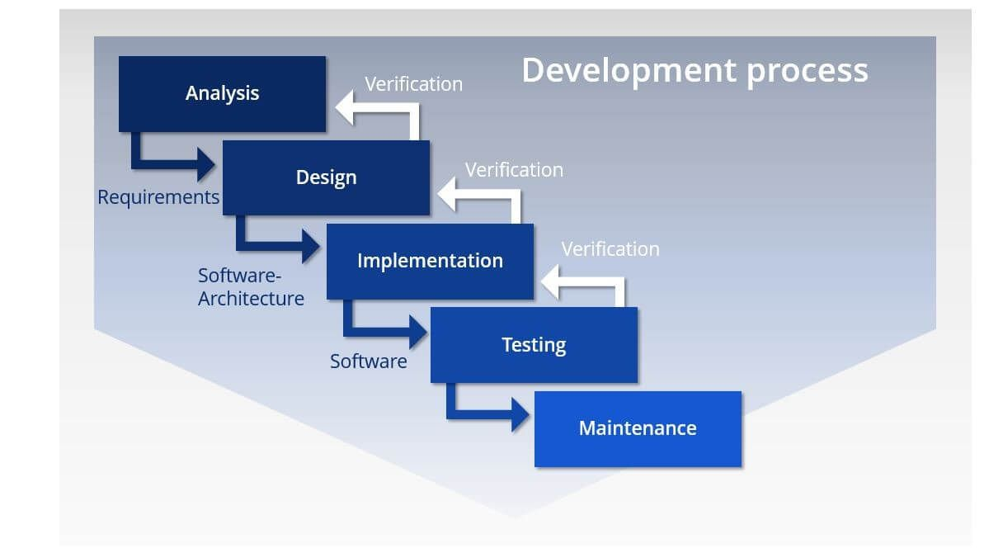
Figure 2Waterfall model

Why does the waterfall model fit this software?
- Simple and small project
- Requirement are fixed
- Simple console based system
- Easy to design step by step
- Suitable for academic project
- Sequential Development process
- Easier testing and debugging

Gantt Chart

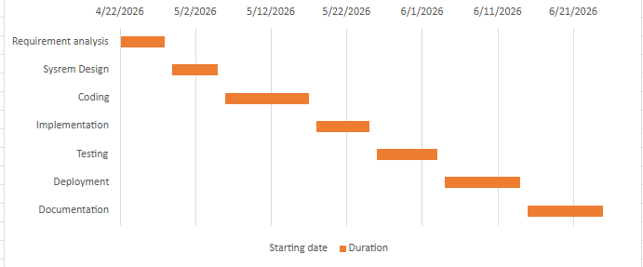
Figure 3Gantt Chart

Conclusion
If we get enough time then we will create a new feature of mobile transaction.
- Include GUI interfaces
- Use Databases
- Use complex data structures.
- Socket programming and computer to computer networking of data
- Barcode software
- More features like data manipulation and data reporting
Basically, think of the possibilities in the future and write it down. Can be brief, or a longer paragraph to describe what can be done. It is up to you.

11. Reference
Final, summary of the documentation, write down the most important components and findings. of each headings.

